Kristopher Saber

Professor Schofield

HCI 500

12/4/2015

Evaluating a GUI

TutorTrac is a website that allows students to schedule tutoring appointments for classes that they are having difficulties with (OLS, 2015). TutorTrac also handles other functions, such as allowing students to log in and out of the system to indicate when they’ve arrived to the appointment and when they’ve left (OLS, 2015). Multiple universities use this system, including S.U.N.Y. Oswego. TutorTrac is handled and managed by the Office of Learning Services, but was bought from a third a party (OLS, 2015). The author of this paper tutors students who use this system, and he himself has to use this website constantly to log in students (OLS, 2015). 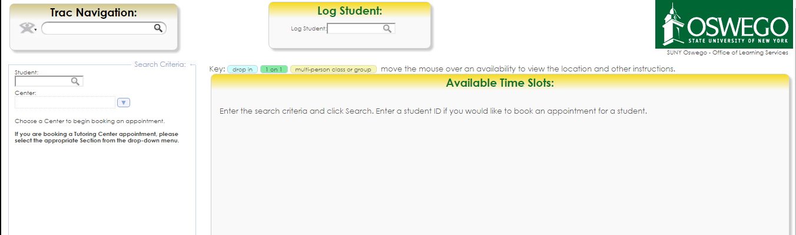

This is the webpage that students use to make an appointment (OLS, 2015). On this page there is a metaphor used three times, in the relatively same context (OLS, 2015). The magnifying glasses on the top left and top middle are both used to signify to the user that there is a search bar. The metaphor is that the magnifying glass means you’re searching for a term or concept, because in general (and in cliché police cartoons), people would use magnifying glasses to search for objects in the physical world. By abstracting something that is known in the physical world to a graphical user interface, users of this website can know that the magnifying glass is a field to search in. The only problem is that not all of them are a field to search in. The “Log Student” field on the top middle of the webpage is used to log a student into the system, which is different than searching for a term or concept (OLS, 2015). Another metaphor that is used on this website is the down arrow which is supposed to signify a drop down menu. This is used in two places on the webpage:

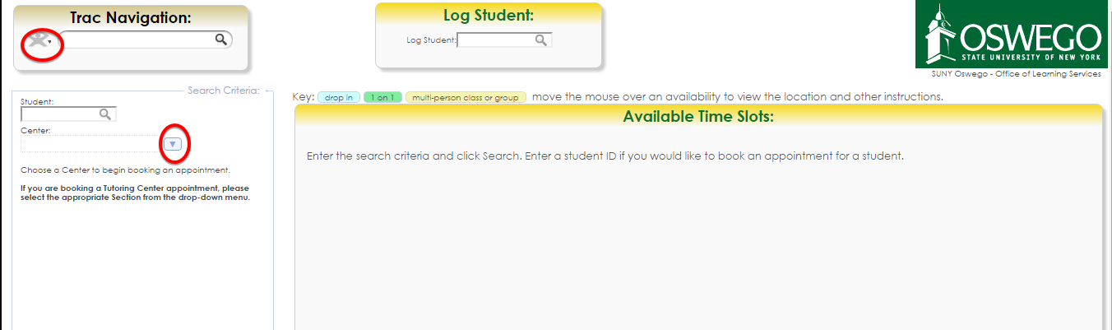

The down arrows that are being referred to are circled in red (OLS, 2015). Both of these arrows lead to a drop down menu, which is what the metaphor is trying to convey (OLS, 2015).

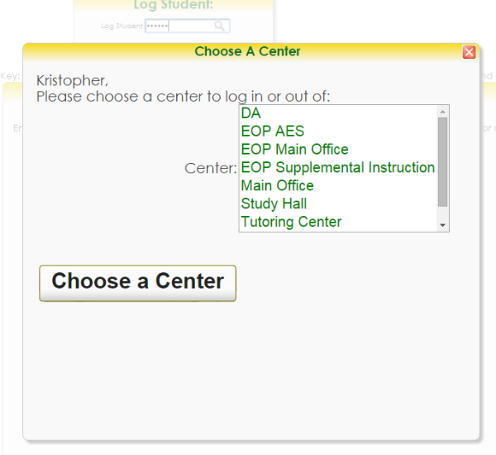 TutorTrac can be evaluated based off of Jacob Nielsen’s Heuristic guidelines. TutorTrac’s form to log a student into the system doesn’t exactly match how a normal sign in sheet would look like in the real world. Where a sign in sheet that would be provided on physical paper contains areas for your name and ID number on a grid like structure, TutorTrac is different in that you enter your ID number into a search bar (Schofield, n.d. & OLS, 2015). Using Nielsen’s second guideline, it can be seen that there are some non-consistent elements on this webpage that need to be redesigned. The magnifying glass is used twice on this website to log a student into the system, and once to signify searching for something in the “Trac Navigation.” There should be something different/altered slightly to signify to the user that they are using the search bars for two different functions; the search bars signify a consistent function because they are represented by the same symbol, even though they don’t perform the same function. A small piece of paper icon metaphor next to the magnifying glass on the “Trac Navigation” search bar might allow users to know that they are searching for a document on the website, and not searching for a student (OLS, 2015). Using Nielsen’s third guideline, help and documentation, it can be seen by looking at this webpage that there is *some* help to allow the user to know how to interact with the website (OLS, 2015 & Schofield, n.d.). In the top middle of the page, it can be seen that there are directions to allow users to know how to view a tutoring availability just in case they aren’t able to figure it out on their own. With the fourth guideline, user control and freedom, it can be seen on this website that users are able to manipulate controls however they see fit (OLS, 2015). Users have the freedom to manipulate any of the controls that are afforded to them. For example, if they think the drop down arrow affords to be clicked, they can go about selecting the dropdown menu without any restriction (OLS, 2015). Tutortrac provides a visible system status that can be interpreted by users. If users enter an ID number into the top middle search bar, the following menu will appear which allows the user to know whether or not they inputted there ID number correctly:

This provides a clear status of the website. In terms of flexibility and efficiency, the TutorTrac website allows user to log into the system with both their Lakernet username and ID number. What this means is that if a user logs himself into the tutor trac system with the Lakernet user name “ksaber” it’ll accept their credentials. Conversely, if they type in their ID number “805333493” the system will recognize and accept their ID number credentials and log them into the system also (OLS, 2015). This allows for flexibility since users can input either identification code to log themselves in (OLS, 2015). In terms of error prevention, there are not many features on the webpage that prevent users from making an error. For example, if users were to search for something irrelevant in the search bar on the top left part of the page, it would bring up a screen that states “Error: document doesn’t exist.” The system gives no indication prior to the search what users can look for in the search box, which allow users to make mistakes searching for things that cannot be found on the system (OLS, 2015). With the eighth guideline, TutorTrac doesn’t make users recall any information except for their ID number or Lakernet user name (OLS, 2015 & Schofield, n.d.). It might be useful to provide recognition for inputting their ID number instead of strict recall; when users input their ID number, a blimp right below the search bar should appear with the name that corresponds to the user’s ID, so they don’t have to select “enter” if they notice they inputted the wrong ID number (OLS, 2015). The ninth guideline, error reporting, diagnosis, and recovery can be applied on the website with the search bar on the top left part of the screen that was discussed previously; if a user types in a wrong key term, all that will appear on the screen is “Error: document doesn’t exist”, which doesn’t allow the user to know what documents should be searched for since it gives the same error regardless of the term searched (OLS, 2015 & Schofield, n.d.). If a user is close to finding the right document, but misspells a word slightly, the error message will still remain the same. Finally, the last guideline, aesthetic and minimal design, can be applied to TutorTrac (OLS, 2015). TutorTrac does go for a minimalist style, allowing for subtle colors (yellow and white) and not too many flashy icons or objects (OLS, 2015 & Schofield, n.d.).

The Office of Learning Services processes tens of appointments a day and the TutorTrac website plays an integral role in logging students into the database, which shows that the website is a functional enough website for people to use currently. Despite this, certain aspects of the website could be improved. The website’s search bars need to be redesigned so that users aren’t confused as to what to search for and where. Changing the magnifying glass metaphor on the top left of the screen to something else that signifies to the user that they are searching for a document might be beneficial so human error can be reduced (OLS, 2015). The website does do a good job of providing flexibility for the user so that they can type in either their ID number or Lakernet ID into TutorTrac, which allow users different ways of logging into the system. Since both forms (ID number and LakerNet ID) are ways of identifying individual students, TutorTrac does a good job of allowing students to sign into the system in multiple ways.

The website keeps the design minimalist, but struggles the most in providing users with error recovery. If a user inputs an incorrect document to search for in the search bar on the top left corner of the screen, the error message that will appear is “error: document doesn’t exist.” Adding functionality that included a “did you mean?” message that would appear on the screen and would display items that could be searched that were similar to the originally inputted message could improve the error recovery rate of users (OLS, 2015). Another aspect of the website that should be improved is the drop down menu on the top left of the webpage, which is small in size. The author of this paper actually didn’t realize there was a drop down menu on the top left of TutorTrac until a year after using the website. By making the dropdown arrow more prominent, users would be able to recognize that there is a dropdown menu in that location. The minimal design that TutorTrac has allows users not to be overwhelmed with the amount of content on the website (OLS, 2015). There aren’t any moving menus except for ones that are selected manually, and the website has blank space which makes the website not overwhelming to users (OLS, 2015). The usability guideline that TutorTrac breaks the least is the minimalistic design (OLS, 2015). Despite the guidelines that were used to evaluate this website, TutorTrac can be improved more effectively through multiple iterations and usability testing sessions; recording users going through TutorTrac and seeing how they navigate on the interface allows real insight on how the design should be improved (OLS, 2015).

References

Schofield, D. (n.d.). *HCI 500: Intro to HCI GUI- Handout (Heuristics)*. Unpublished typescript, State University College at Oswego, Oswego, NY.

Office of Learning Services. (n.d.). Tutor Trac Main Menu. Retrieved December 3,2015, fromTutorTrac website: https://oswego.tutortrac.com/tracweb40/main.4sp